**Grading Rubric - Analysis**

Name: Travis Moore

Title of Paper: Hellboy: Volume 1 Analysis

**Correct Format (2 pts. each, 14 total):**

____Rubric attached

____Times New Roman 12 pt. font double spaced

____Standard margins

____Paragraph indents

____No extra spacing between paragraphs

____Word count typed in heading

____Adherence to word count

**Content (46 pts. total):**

____Adherence to topic

____Background

____Analysis of art

____Analysis of transitions

____Analysis of space usage

____Analysis of text usage

____Overall opinion

**Grammar/mechanics (1 pt. each, 40 total):**

____1 pt. deduction for each error

**___________Total**

**Background**

*Hellboy* is a graphic novel created by the writer and artist Mike Mignola that features a superhero demon named Anung Un Rama, who goes by the nickname of “Hellboy”. Hellboy is summoned from hell to earth as an infant by Nazi occultists during the waning years of World War II in an attempt to try and gain a supernatural upper hand in winning the war. Fortunately, Hellboy is discovered by Allied Forces where he grows up to become the “World’s Greatest Paranormal Investigator” for the Bureau for Paranormal Research and Defense, otherwise known as the BRPD. While Hellboy is a large, brutish demon with an oversized right hand made of stone, he is otherwise kind towards humans with a strong sense of humor and sense of loyalty towards his adopted governmental family. Mike Mignola’s *Hellboy* is strongly influenced by Lovecraftian horror, dark forces, and adventure, with a nice sprinkle of humor to lighten it up.

*Hellboy Volume I* consists of the stories *Seed of Destruction* and *Wake the Devil* which set the stage for how Hellboy came to be and journey of self-discovery. In *Seed of Destruction,* the past events leading to Hellboy’s summoning to earth are explained and the main antagonists are introduced. The story then picks up at the current time where the reader is presented Hellboy and the other BPRD agents he calls family. The story concludes with Hellboy learning about his conception and destiny while battling one of the antagonists, Rasputin, at the Cavendish Hall mansion. *Wake The Devil* sees Hellboy further exploring his purpose in Romania while investigating the theft of the coffin containing a Napoleonic officer who was believed to be a vampire before his death. Hellboy’s resolve is put to the test as he denounces his dark purpose and defeats the vampire and the ancient goddess Hecate.

**Analysis of Art**

Alan Moore describes Mike Mignola’s art style as “German Expressionism meets Jack Kirby” in the forward to *Wake the Devil*. Jack Kirby’s influence can be seen in Mike Mignola’s blockier lines, deep shadows, and dramatic posing of his characters during fight scenes. The influences of German Expressionism are subtler, as Mike Mignola does not distort the perspective of shapes to evoke emotion as radically as Expressionism artists typically do. Instead, Mike Mignola’s use of color in backgrounds and limited, yet focused use of detail exaggerates the atmosphere of his comic panels in ways that instantly set the mood for his artwork.

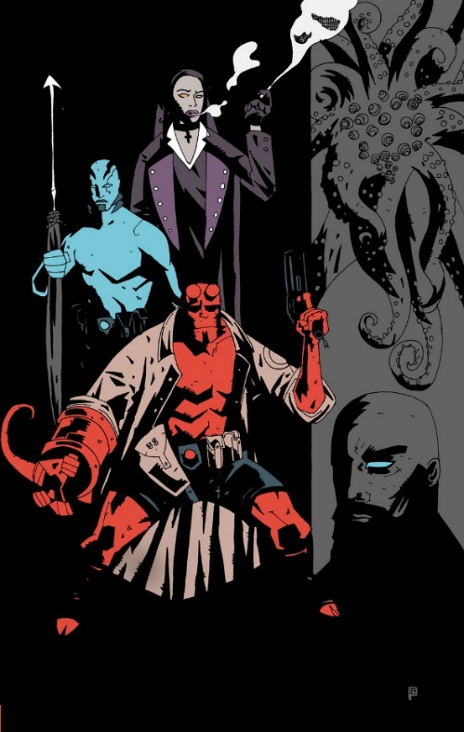

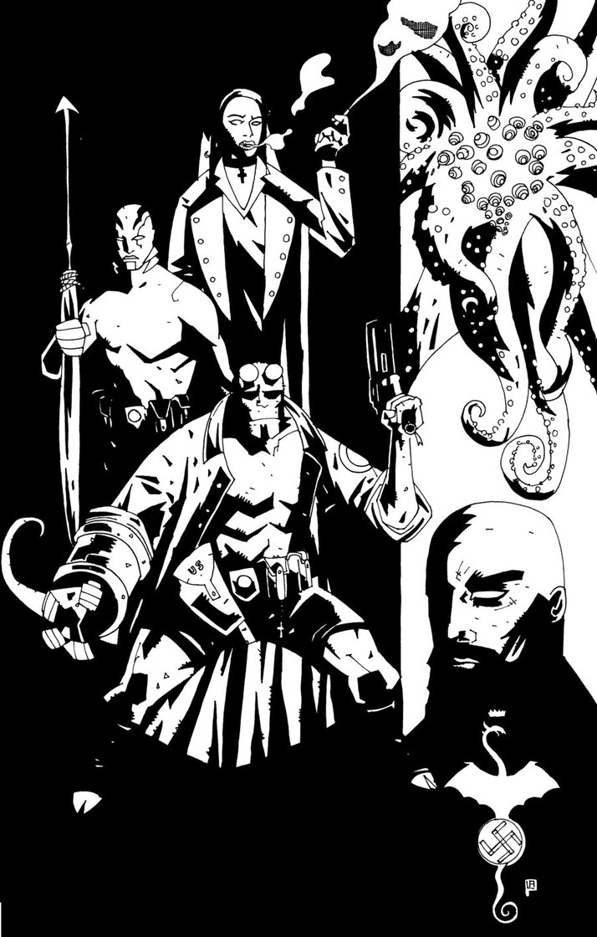

The line quality contrasts heavily with the use of shape in such a magnificent way in *Hellboy*. The line quality is quite consistently thin, with an even amount of geometric angles and organic lines. The use of line is usually kept to minimal for characters in scenes, except for when trying to exaggerate or emphasize a mood or quality. For example, eldritch-like horrors, whether characters or as architecture in the background, generally receive more line treatment. The additional lines used for horrific creatures and architecture are used to show that they are slimy, spikey, or otherwise nasty in otherworldly ways. This is especially notable for the character Abe, who is half amphibian. While Abe’s lines are kept to a minimal, the other amphibious frog-creatures are riddled with lines to show that they are spikey and horrific. The shapes in *Hellboy* are large, chunky, and very dramatic. A lot of the power behind many of the scenes comes from the poses that are defined by the shapes and in the areas of solid black shadow. *Hellboy* is rife with silhouette shapes that help define what is foreground and background, as well as set a dark and mysterious mood to the story as a whole.

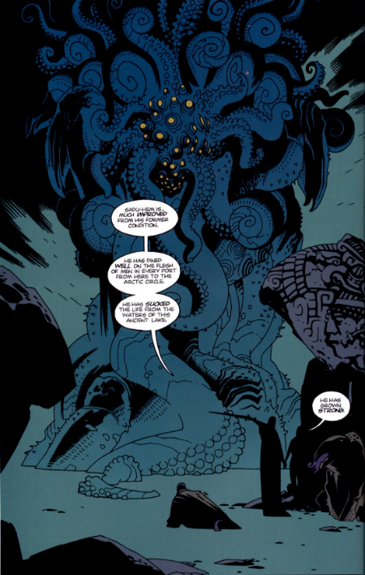

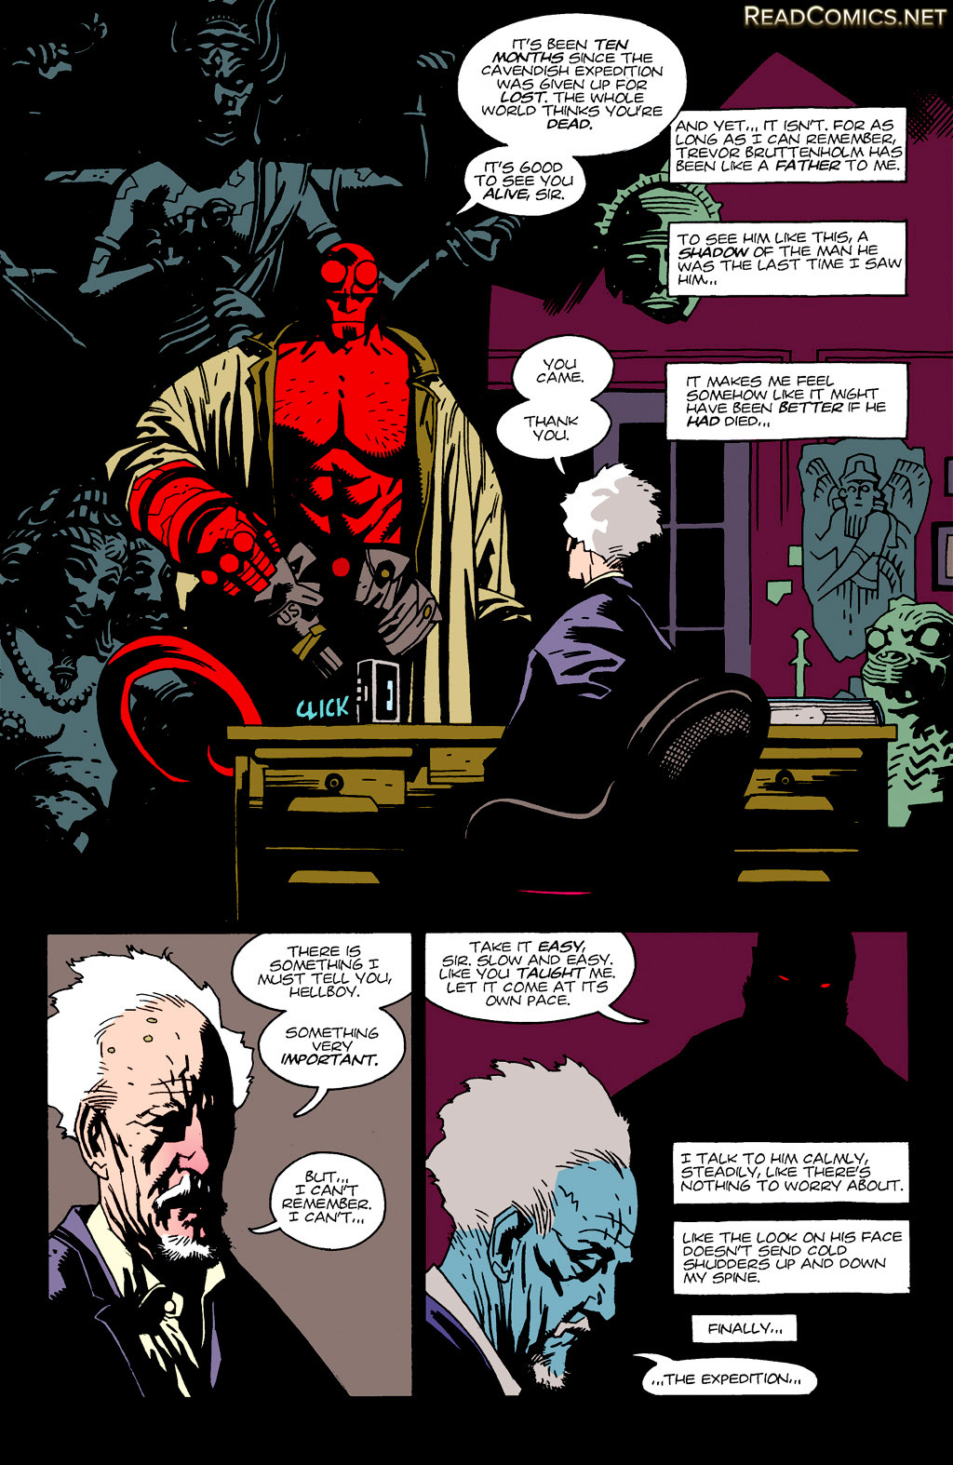

Large, cel shaded blocks of color give *Hellboy* a very flat appearance. Characters are mostly one primary color with an accent color that is usually their clothing or eyes. This simple use of color helps keep *Hellboy* from being visually overwhelming. Friendly characters tend to be semi-bright, warm colors, while evil characters and architecture tend to be dark, cool colors. Where color really shines in *Hellboy* is in conveying the atmosphere and mood of a scene. During lulls in the action the use of a cold color palette controls the scene. The cold colors often envelope the characters, shifting their usual colors to show them being swallowed up in the mood of the environment. When extreme bright colors are used, they are reserved for explosive action and really catch the eye due to being seldom used in *Hellboy*.

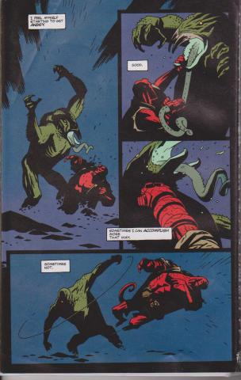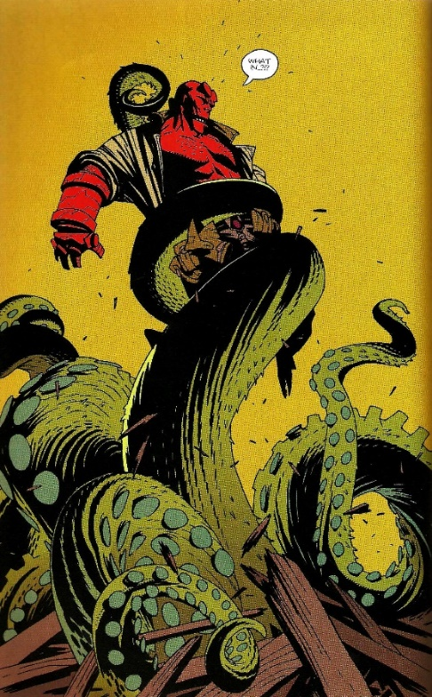

The art style of *Hellboy* often appears very graphic, with a lot of static scenes that feel posed. Action scenes break up this static feeling with the use of very dramatic character posing. Composition throughout *Hellboy* can often feel a bit lazy due to most of the perspectives being very straight forward. Depth within scenes is often conveyed through solid black silhouettes or through a single atmospheric color that represents the background. Motion is conveyed with lots of thin action lines, splatter-like circle shapes, or through the dynamic quality of the character poses. There are a few times where sound effect words are used to give a sense of motion to a scene, but it is extremely rare.

**Analysis of Transitions**

*Hellboy* moves very fast, and as such, closing the gap between panels can sometimes be difficult. There are many times when scene-to-scene transitions ask the reader to make jumps to a different set of characters in a similar looking location or a flashback to a different moment in time. This problem is especially prevalent in *Wake the Devil*.Thankfully, *Hellboy* uses color very similarly to *The League of Extraordinary Gentlemen*, in that each scene usually has a color theme that is used to set the mood of the location. Without this color technique it could be easy to get lost in where everyone is and what is happening.

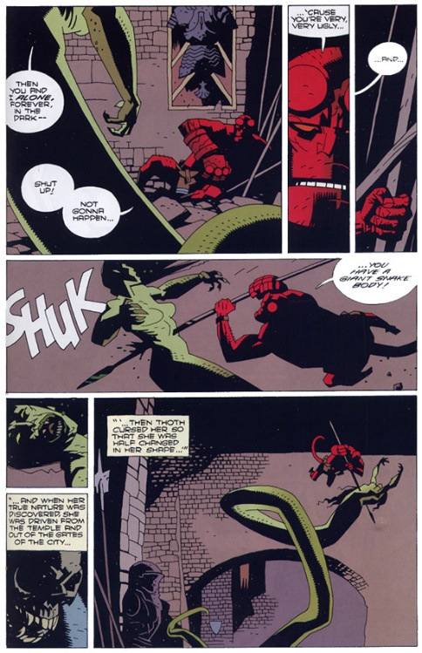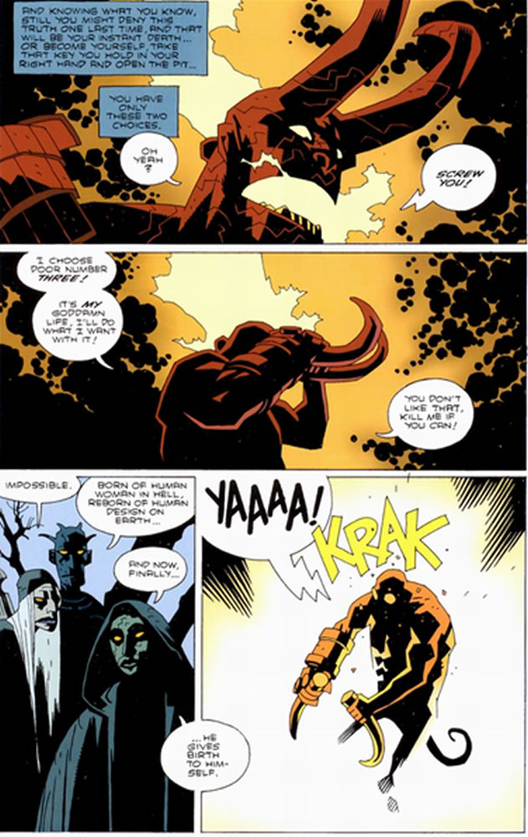

Other than the scene-to-scene transitions, most of the graphic novel is done using action-to-action transitions. These transitions follow what Hellboy or the other characters are currently doing in the scene. However, sometimes the action-to-action transitions have moments of aspect-to-aspect littered in that are added for interest or mood. This sudden shift can make it difficult to understand what just happened. Thankfully, the panels go back to action-to-action rather quickly so the reader can catch back up. However, these rare moments are quite confusing at times.

**Analysis of Space**

*Hellboy*’s use of space is generally easy to follow and follows the standard left to right, top to bottom reading style that is typically of western graphic novels. When there is very little action going on there tends to be two to three larger panels that are either cropped tightly on a character’s face to convey the emotion of the scene or a zoomed out shot to establish the location of the characters of the scene. Roughly half of the pages in *Hellboy: Volume I* consist of this style of traditional layout. The other half of the pages tend to take more liberty in how to layout a scene. These different layouts usually emphasize one giant panel of action or significance and pepper smaller panels into the layout. This change of pace can be more work to the reader, but it provides an interesting variety to *Hellboy* that is worth the extra effort of understanding the sequence of the panels. It is worth noting that *Seed of Destruction* has all black gutters while *Wake the Devil* has traditional white gutters. Due to the dark and mysterious nature of *Hellboy*, the black gutters tend to really work well compared to the white gutters.

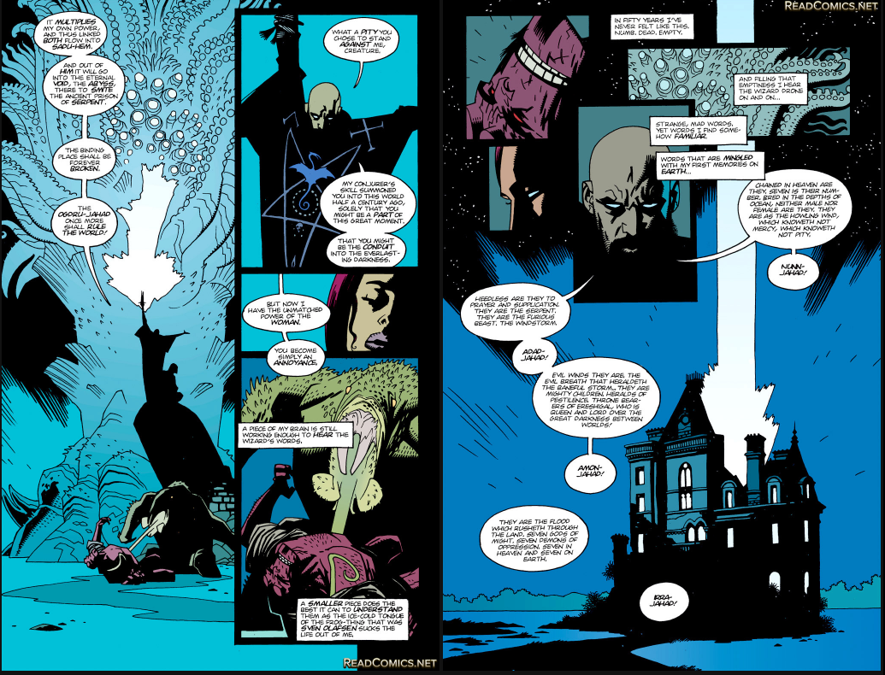

**Analysis of Text Usage**

Text usage in *Hellboy* is mostly minimal and flips frequently between present tense conversational or third-person past tense reflection given from Hellboy’s point of view. The bulk of the story is given to the reader from what the antagonists are planning and they tend to speak the majority of text because they know more about what is happening than Hellboy does. The present tense text is used when people are speaking to Hellboy, otherwise when Hellboy is by himself travelling through and area the past tense reflection of what Hellboy was thinking at that time is used. Due to the frequent use of past tense reflection from Hellboy, the reader really gets to connect and understand Hellboy, especially compared to the other friendly characters. When Hellboy does speak, his wordage is usually gruff and short. Hellboy is more of a demon of action, rather than a poet.

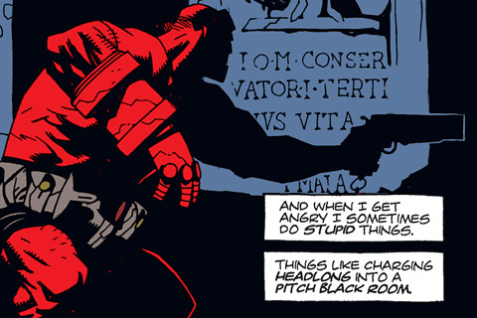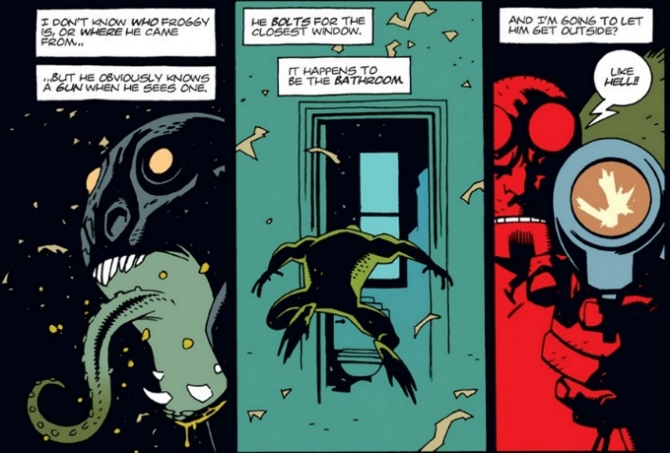

Outside of Hellboy’s conversation and self-reflection, there are rarely moments of text being used to convey anything else. At the beginning of both *Seed of Destruction* and *Wake the Devil* there are a few pages that provide a narration to the events that have led to the start of the story. This narration is set in a serif font that is different than any of the other fonts used in the graphic novel. This text is usually given its own panel and feels more like reading pages of a book. There are a few moments where explosions are given a “boom” or a “krak”, but for the most part the action of sound effects is kept quiet through text and the artwork is allowed to speak for itself.